Project: | Todo Application
Course: | CSD 380
Description: | Test Cases for Todo Application
Date: | 1/18/2026
To complete the test case plan, fill out the information for Project, Course, Description and Date in the header below.

TABLE OF CONTENTS
Create a new todo task item 2
View a list of todo task items 3
Delete a todo task item 3
Edit a todo task item 4
Custom 404 Link 4

For each test, the developer should: provide a test description, a test objective, the developer name and date tested. For each step, fill out the actions to be taken and describe the expected results, and indicate yes or no for each step depending upon the result. The peer tester should provide their name, date tested, indicate yes or no for each step depending upon the result, and a screenshot (thumbnail) of the result.

Test 1 | Create a new todo task item
 | Test Objective: Create a new todo task item | Developer: Kate Graham  Date tested: 1/18/2026 | Peer tester: Natasha Foreman  Date tested: 1/18/26
Step | Action | Expected results: | Developer pass/fail | Tester pass/fail  + Screenshot
1 | Navigate to https://buwebdev.github.io/todo/ | Site Loads | <yes/no> | Yes  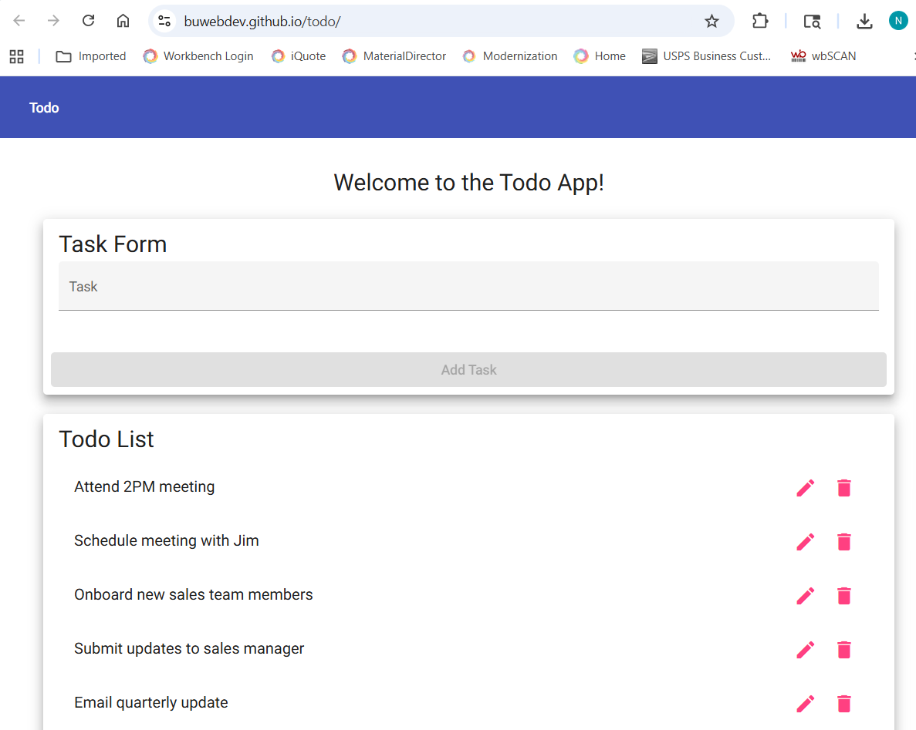
2 | Do not enter anything in Task field and attempt to submit. | System does not allow submission |  | Yes
3 | Type a Task (>4 characters) into The “Task” field of Task Form and Click “Add Task” | Task appears in the Todo list | <yes/no> | Yes  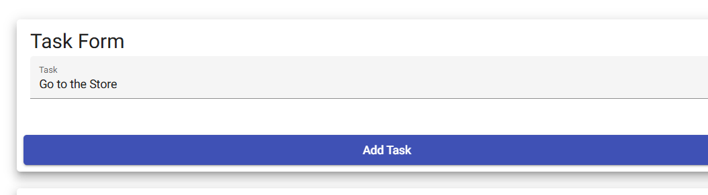
4 | Repeat 1&2 | Multiple tasks appear in the Todo List | <yes/no> | Yes  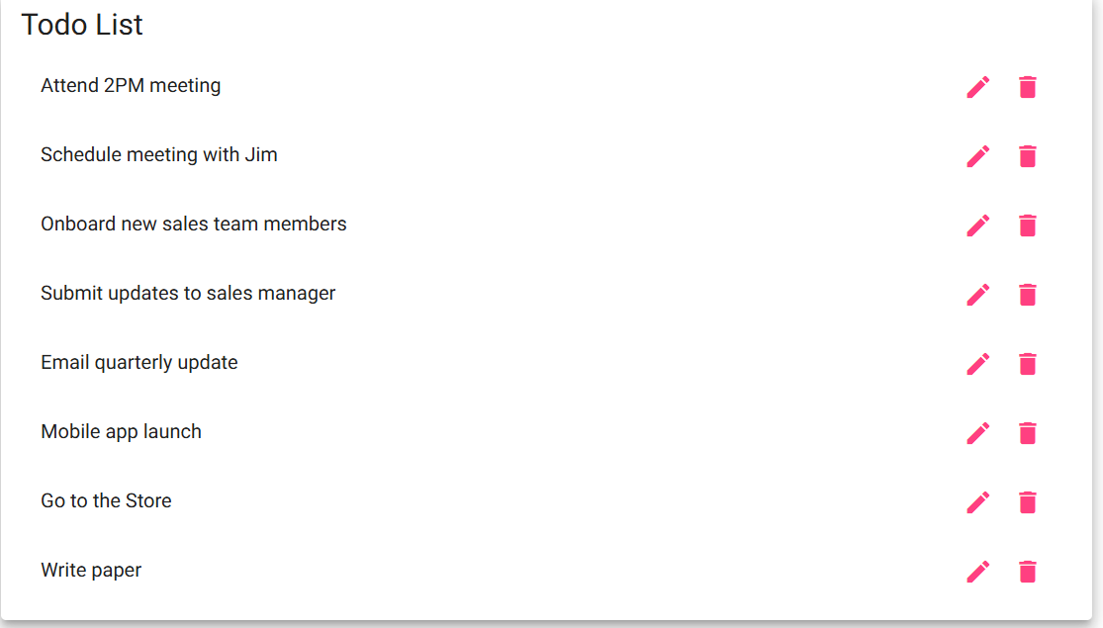
Comments | Comments should be substantive; this means there should be at least 2-3 well-structured sentences with constructive feedback.

Test 2 | View a list of todo task items
 | Test Objective: View a list of todo task items | Developer: Kate Graham  Date tested: 1/18/2026 | Peer tester: Natasha Foreman  Date tested: 1/18/26
Step | Action | Expected results: | Developer pass/fail | Tester pass/fail
1 | Navigate to https://buwebdev.github.io/todo/ | Site Loads | Yes | Yes
2 | View tasks | Tasks should be available to view | Yes | Yes
Comments | Comments should be substantive; this means there should be at least 2-3 well-structured sentences with constructive feedback.

Test 3 | Delete a todo task item
 | Test Objective: Delete a todo task item | Developer: Kate Graham  Date tested: 1/18/2026 | Peer tester: Natasha Foreman  Date tested: 1/18/26
Step | Action | Expected results: | Developer pass/fail | Tester pass/fail
1 | Navigate to https://buwebdev.github.io/todo/ | Site Loads | Yes | Yes
2 | Type a Task (>4 characters) into The “Task” field of Task Form and Click “Add Task” | Task appears in the Todo list | Yes | Yes
3 | Click on the trash can next to the Todo List item | Item should be removed from the list | Yes | Yes  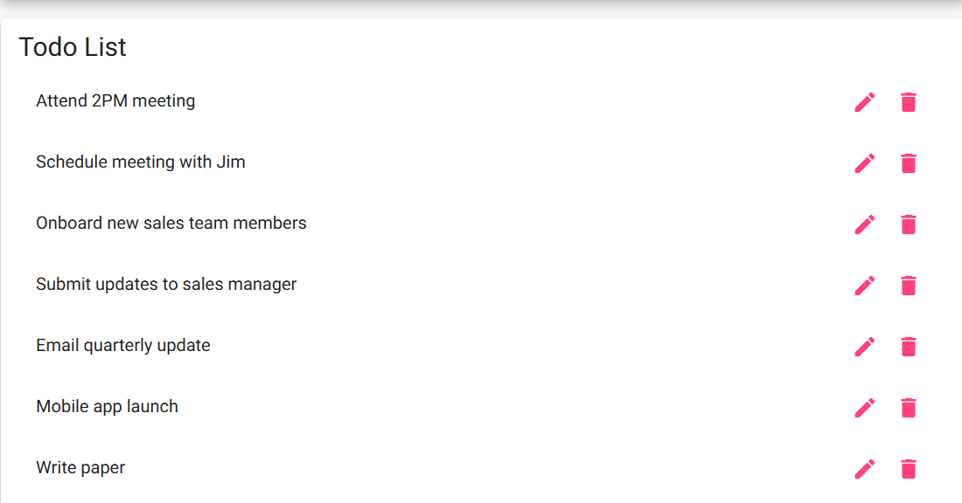
Comments | Comments should be substantive; this means there should be at least 2-3 well-structured sentences with constructive feedback.

Test 4 | Edit a todo task item
 | Test Objective: Edit a todo task item | Developer: Kate Graham  Date tested: 1/18/2026 | Peer tester: Natasha Foreman  Date tested: 1/18/26
Step | Action | Expected results: | Developer pass/fail | Tester pass/fail
1 | Navigate to https://buwebdev.github.io/todo/ | Site Loads | Yes | Yes
2 | Type a Task (>4 characters) into The “Task” field of Task Form and Click “Add Task” | Task appears in the Todo list | Yes | Yes
3 | Click on the pencil can next to the Todo List item and remove all characters from the task name | System will not allow submission | No | Yes  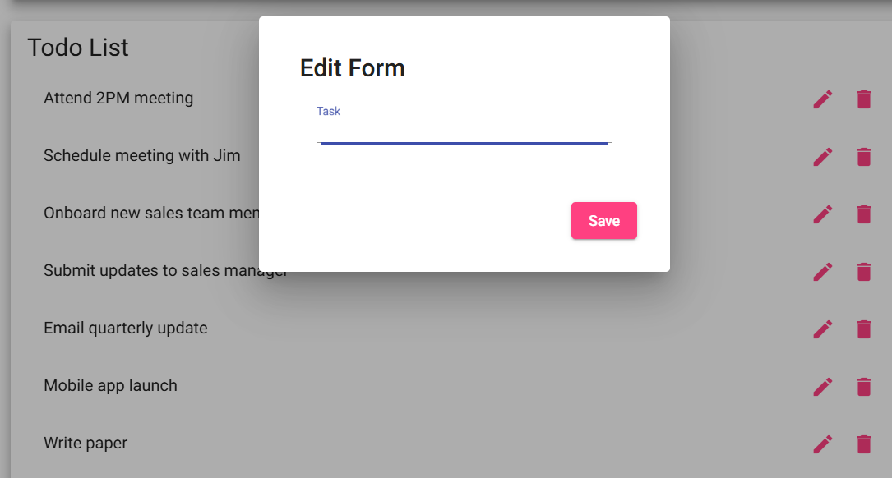
4 | Click on the pencil can next to the Todo List item and modify task name | Task name will be modified | Yes | Yes
Comments | Comments should be substantive; this means there should be at least 2-3 well-structured sentences with constructive feedback.

Test 5 | Custom 404 Link
 | Test Objective: For invalid URLs, provide users with a custom 404 error page | Developer: Kate Graham  Date tested: 1/18/2026 | Peer tester: Natasha Foreman  Date tested: 1/18/26
Step | Action | Expected results: | Developer pass/fail | Tester pass/fail
1 | Navigate to https://buwebdev.github.io/todo/123 | “not-found works!” appears on the page | Yes | Yes
Comments | Comments should be substantive; this means there should be at least 2-3 well-structured sentences with constructive feedback.

